

NAME: NATASHA WANJIRU THUNGU.
ADM NO: BSCCS/2024/53895.
UNIT CODE: BIT3208.
UNIT: ADVANCED WEB DESIGN AND DEVELOPMENT.
DEPARTMENT: COMPUTING AND INFORMATICS.

LECTURER: MR. NYORO.
YEAR, SEM: 2026, May/Aug.
DECLARATION.
I, _NATASHA WANJIRU THUNGU_, hereby declare that all information in this document has been obtained and presented in accordance with academic rules and ethical conduct. Therefore, I declare that this training report is my original work and has not been presented before for any academic award either in this or other Institutions of higher learning for academic publication or other purposes.

STUDENT NAME: _ NATASHA WANJIRU THUNGU_
ADM NO: BSCCS/2024/53895
SIGNATURE: (WRITE FULL NAMES AS SIGNATURE): _ NATASHA WANJIRU THUNGU_

GITHUB REPOSITORY: https://github.com/natashanats170-sudo/Advanced-Web-Design.
TABLE OF CONTENTS.
Week 1: Environment Setup. 3
Week 2: Wireframes, GUI Design, and Project Planning. 5
Week 3: JavaScript Basics, Form Validation, and PHP Introduction. 6
Week 4: Server-Side Components and Backend Development. 8
Week 5: Databases and CRUD Foundations. 10

TABLE OF CONTENTS. 2
Figure 1: XAMPP Control Panel with Apache and MySQL Running. 3
Figure 2: Hello World PHP Page Running in Browser. 4
Figure 3: Successful Database Connection Test. 4
Figure 4: Dashboard Wireframe. 5
Figure 5: Figma High-Fidelity GUI Design. 5
Figure 6: Registration Form Showing Validation Error Messages. 6
Figure 7: JavaScript Validation Code in VS Code. 7
Figure 8: PHP Code Examples Running in Browser. 7
Figure 9: Login Page Interface in Browser. 8
Figure 10: Login Processing PHP Code and Response. 9
Figure 11: votingdb Database Created in phpMyAdmin. 10
Figure 12: Three Tables Created in phpMyAdmin. 10
Figure 13: PHP Connection String Code. 11

Week 1: Environment Setup.
Install XAMPP to run Apache and MySQL locally, creating a development server environment on your machine.
Figure 1: XAMPP Control Panel with Apache and MySQL Running.
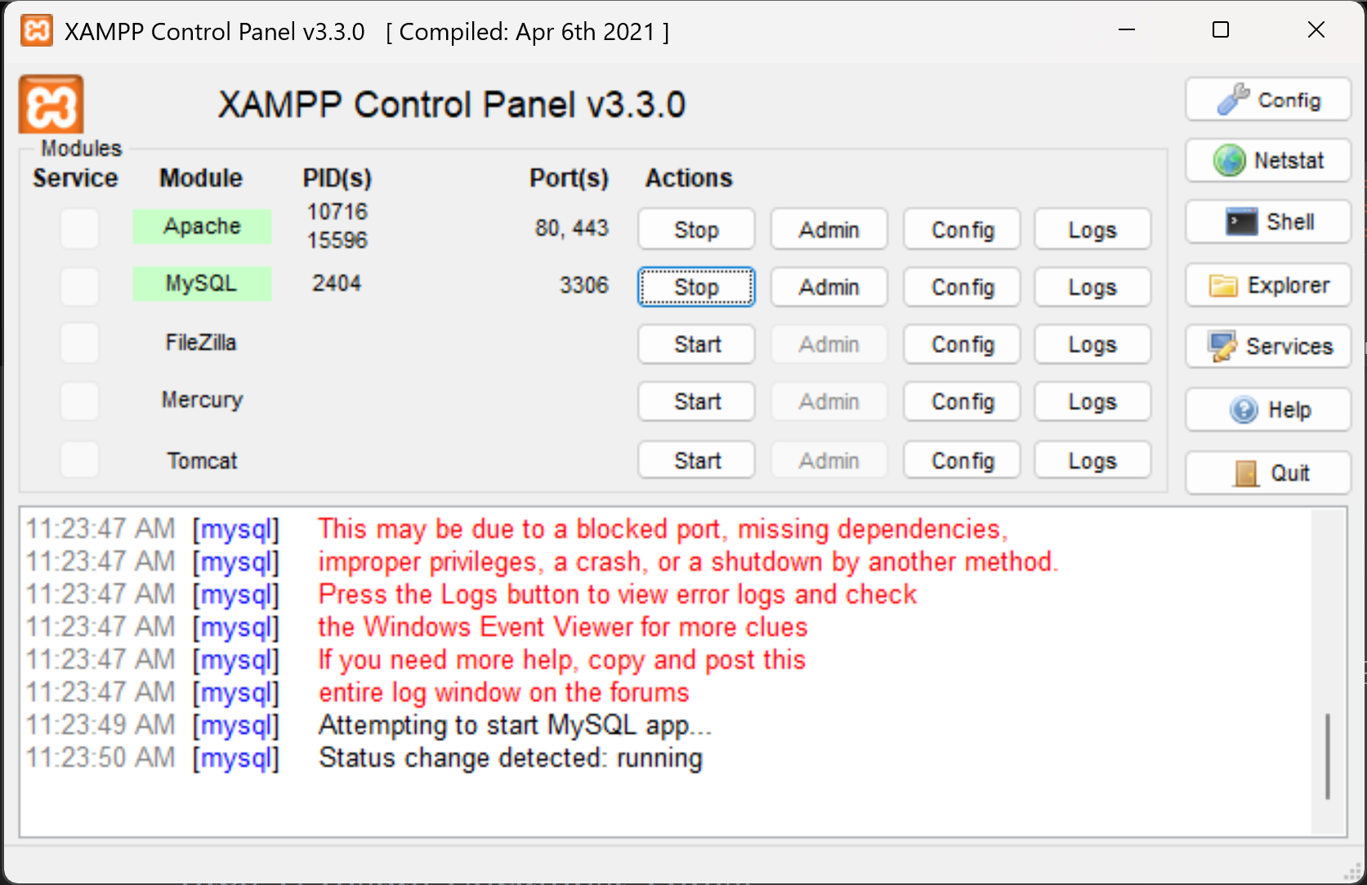
Figure 2: Hello World PHP Page Running in Browser.

Figure 3: Successful Database Connection Test.
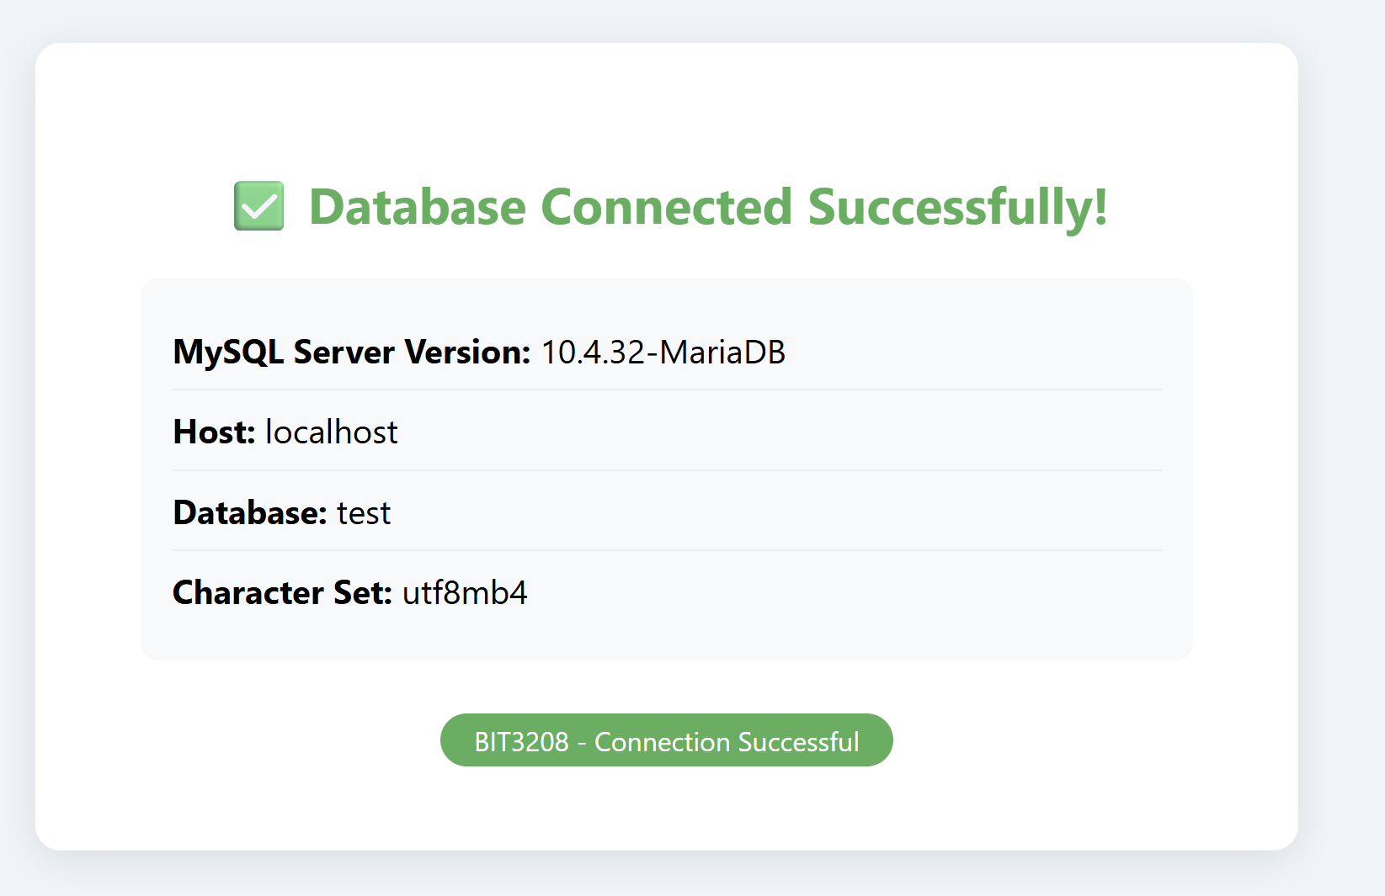

Week 2: Wireframes, GUI Design, and Project Planning.
This week covers the design phase of web development. Before writing any code, professional developers plan the visual layout and user experience using wireframes. We will design key pages and establish our project structure.
Figure 4: Dashboard Wireframe.
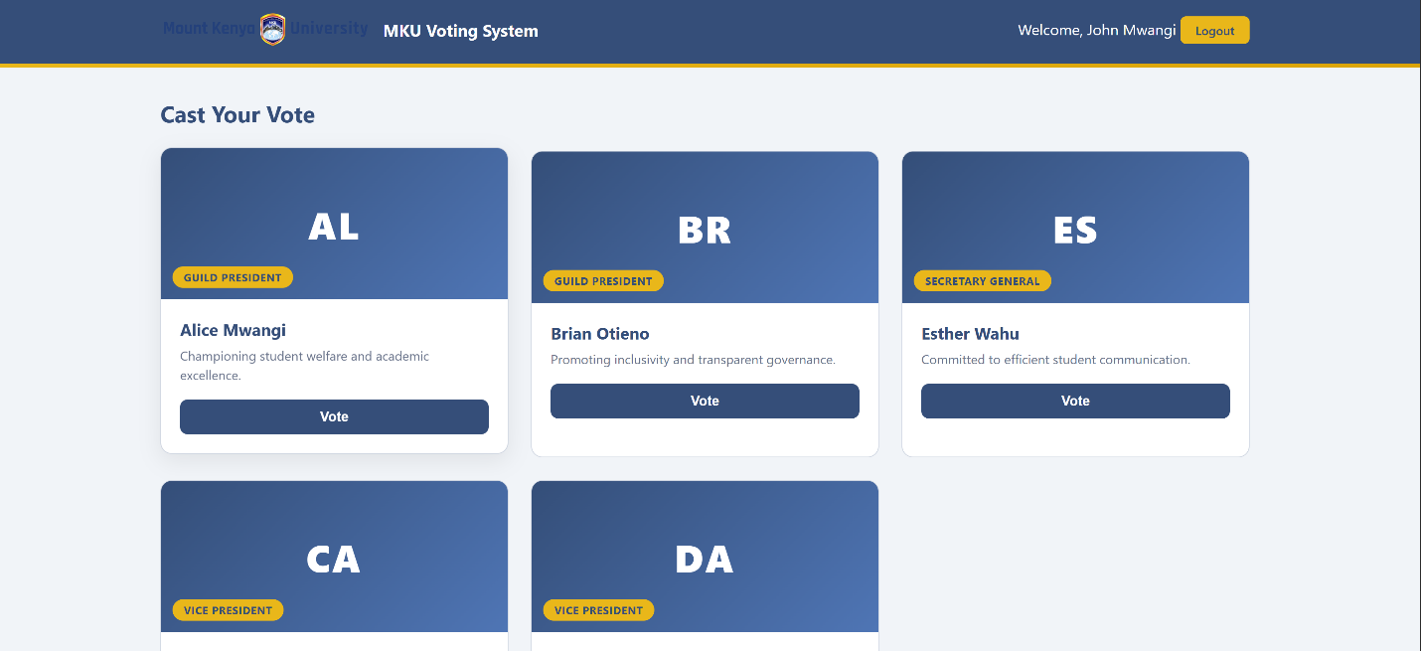
Figure 5: Figma High-Fidelity GUI Design.
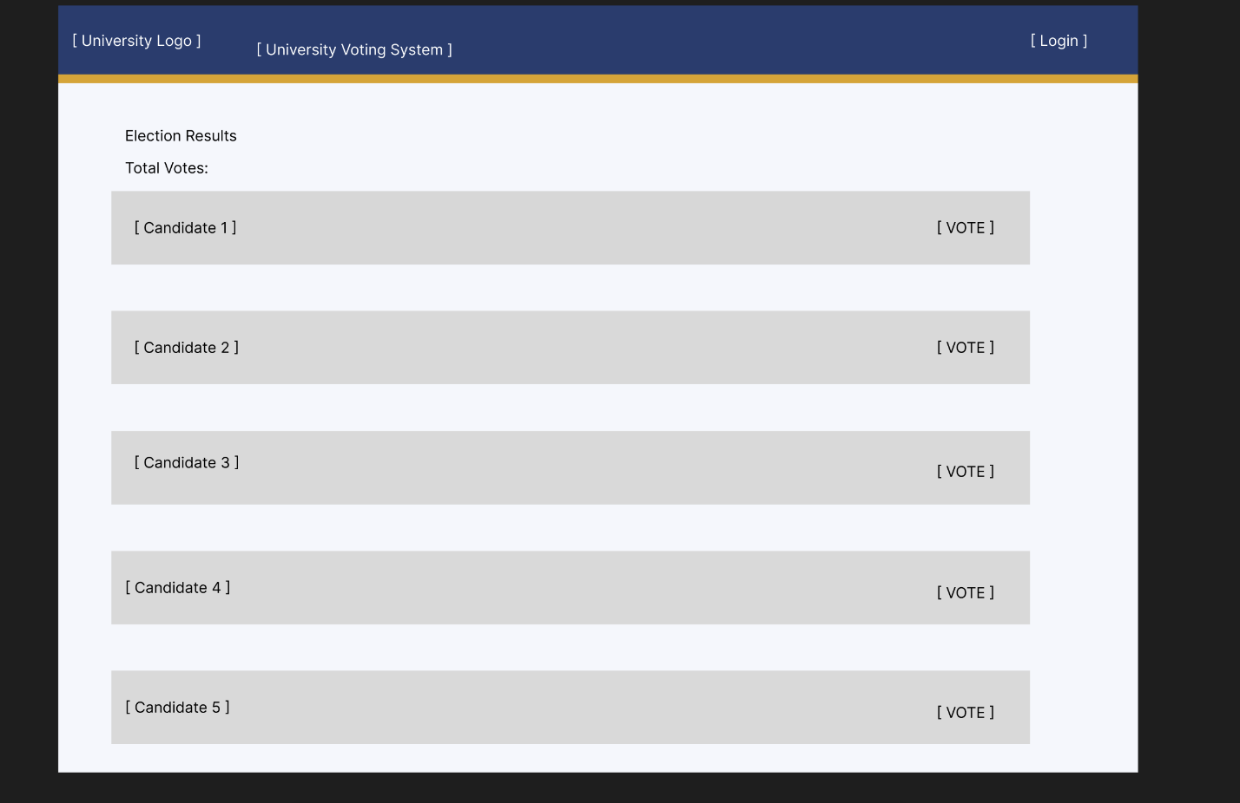

Week 3: JavaScript Basics, Form Validation, and PHP Introduction.
This week introduces two core technologies: JavaScript for client-side interactivity and PHP for server-side processing. We focus on form validation as a practical bridge between the two.
Figure 6: Registration Form Showing Validation Error Messages.
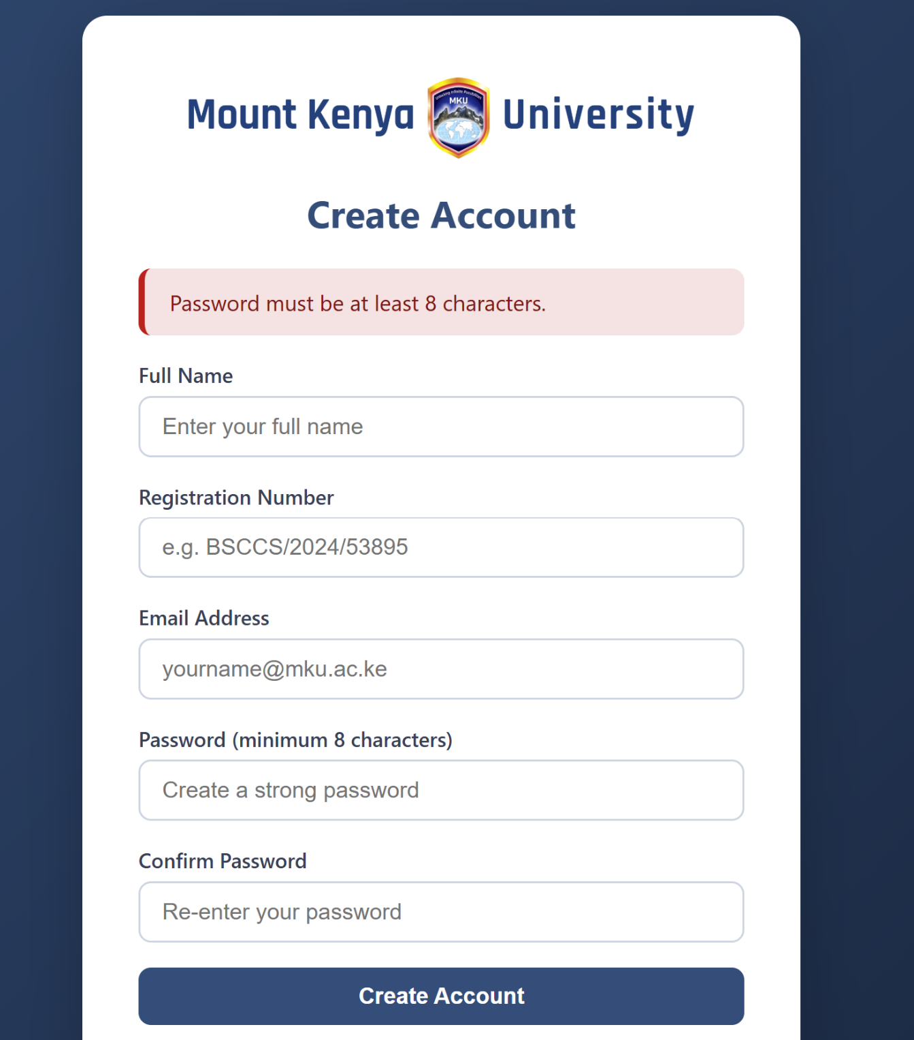
Figure 7: JavaScript Validation Code in VS Code.
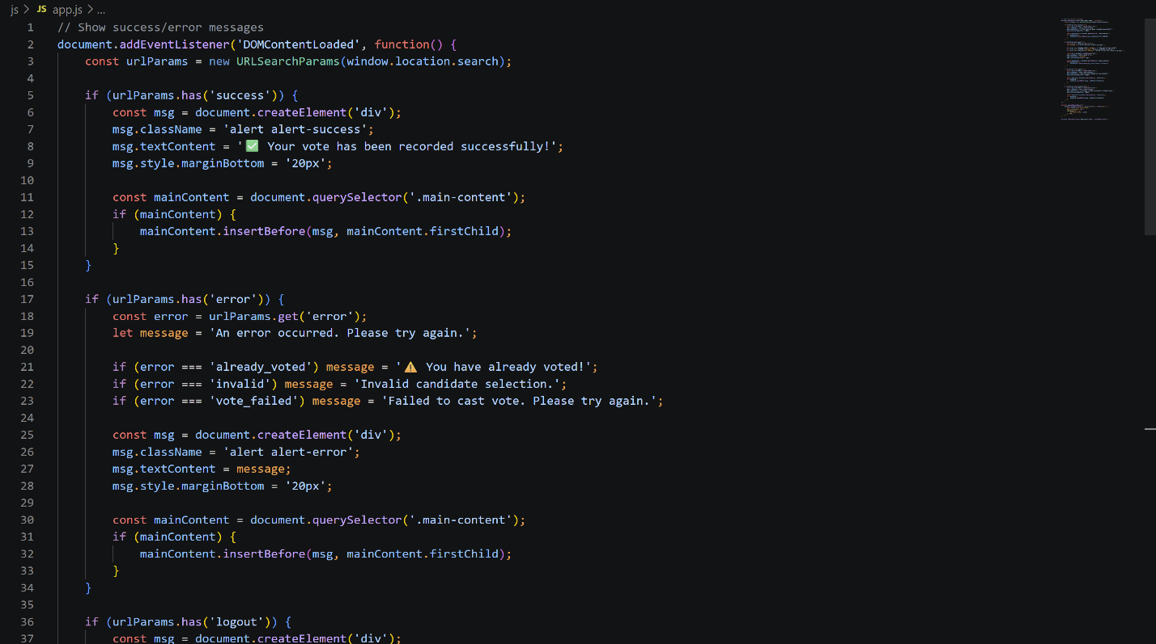
Figure 8: PHP Code Examples Running in Browser.
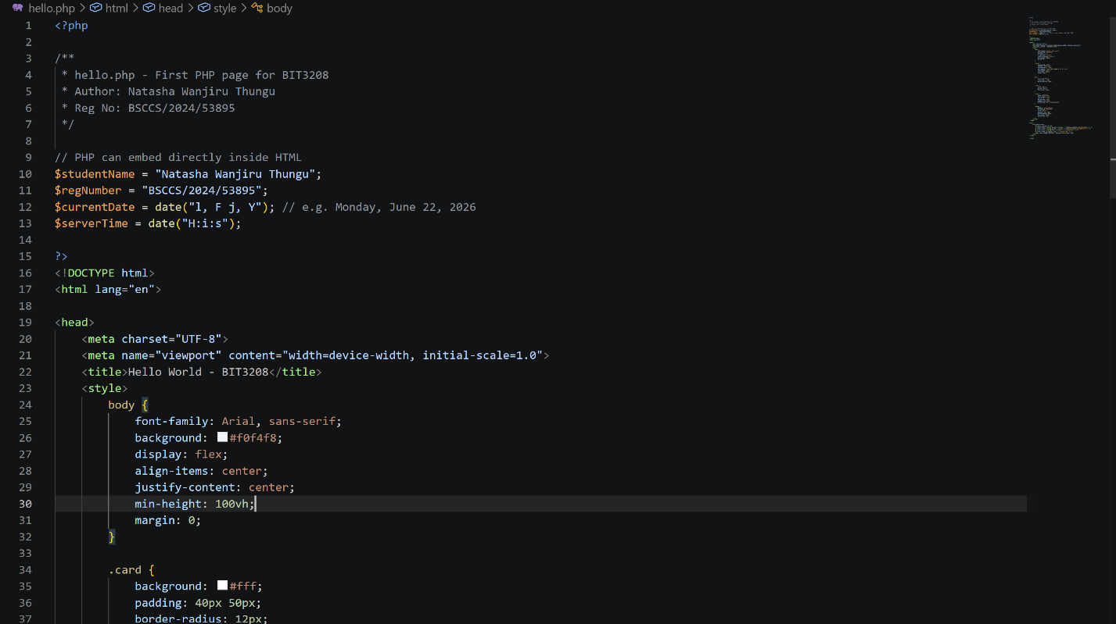

Week 4: Server-Side Components and Backend Development.
This week bridges HTML forms with PHP backend processing. We implement GET vs POST methods, server-side form handling, and build a basic (non-database) authentication prototype.
Figure 9: Login Page Interface in Browser.
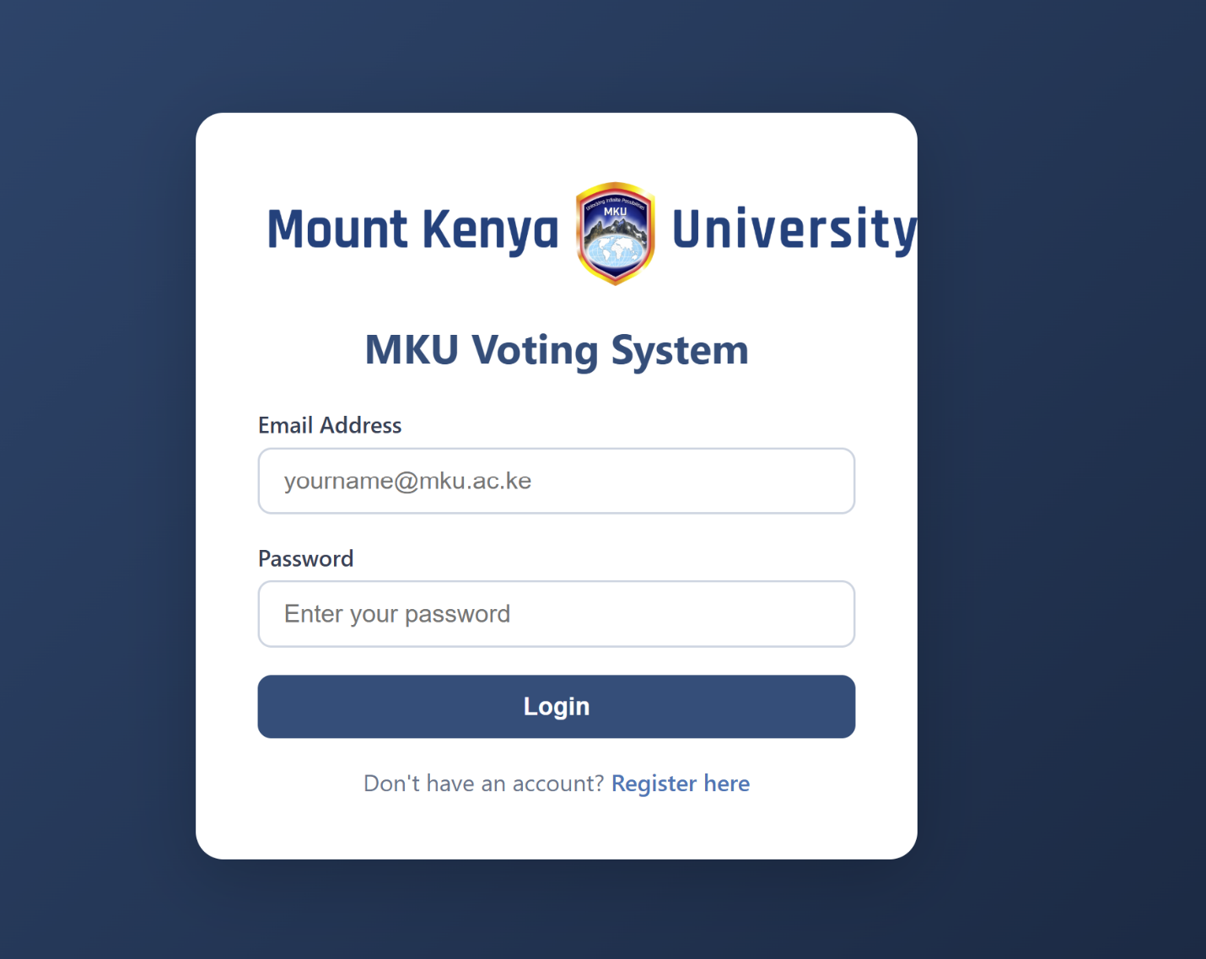
Figure 10: Login Processing PHP Code and Response.


Week 5: Databases and CRUD Foundations.
This week covers relational database design, table creation, relationships, and normalization , the essential theory and practice before building database-driven applications.
Figure 11: votingdb Database Created in phpMyAdmin.
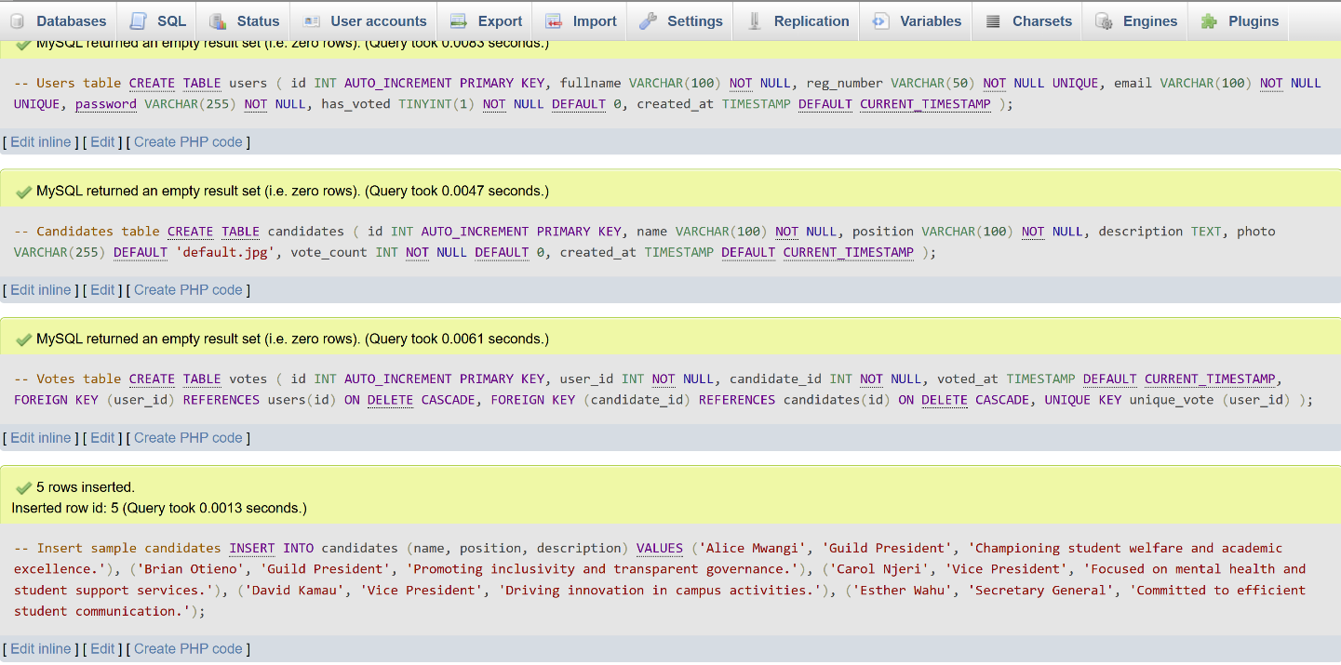
Figure 12: Three Tables Created in phpMyAdmin.
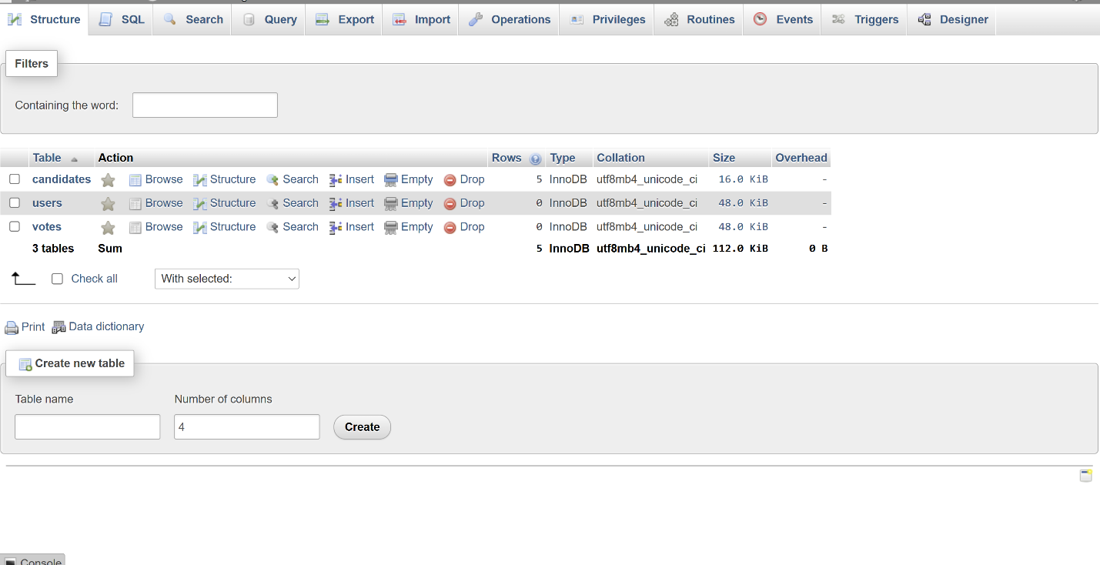
Figure 13: PHP Connection String Code.
